03.02
Work Package Generation
Process Design & AMOS Configuration Document
Purpose
This Process Design document is provided to Key-Users to record their key decisions regarding the AMOS Process design and the required AMOS configuration.
It is updated throughout the Project Definition Phase and used as the baseline for the Final Acceptance prior to Go-Live
Revision
Author, Name | Date | Notes
Adriano Azzurretti | 01.06.2024 | First Version

Table of Contents

1. Process Overview & Objectives 3
2. Regulatory References 3
3. Definitions & Glossary 3
4. Process Tasks 3
5. Process Dependencies 4
6. Process Flow 5
7. Process Design Questions 7
8. Data (Source) Mapping 8
9. Other Software Used 8
10. AMOS Configuration 9
a. Basic Data 9
b. Parameters 9
c. Workflows 11
d. Scheduled Tasks 11
e. API’s & Interfaces 12
11. UAT Guidance 12
12. Annex – Additional Info 12

Process Overview & Objectives

Process General Description:
The process concerns the assignment of tasks to Work Packages, with the aim to perform the fleet maintenance activity in respect of the continuous airworthiness and the commercial and technical constraints involved.
Main Process Objective (Outputs & Outcomes):
The main objective of the process is to collect maintenance tasks into work packages to be executed within corresponding maintenance layovers. The collected tasks shall abide by the main constraints in terms of due values, layover duration (aircraft availability), available resources (including facilities), reasonable use of the maintenance intervals to avoid over-maintenance and to minimise commercial and technical impacts.
The product of the Business Process is a referenced list of the tasks to be performed by an internal or external maintenance provider (MRO) within a corresponding layover.
As the case may be, the process is reiterated more than once for a single layover in order to provide the MRO with further (and more accurate) revisions of the content of the same Work Package as the induction date approaches.

Regulatory References

- EASA Part M - Subpart B M.A.201 Responsibilities
- EASA Part M - Subpart C M.A.301 Continuing airworthiness tasks
- EASA Part M - Subpart C M.A.303 Airworthiness Directives
- EASA Part CAMO - CAMO.A.315(b)(5) Continuing airworthiness management
- FAA Title 14 CFR § 121.363 Responsibility for Airworthiness
- FAA Title 14 CFR § 91.405 Maintenance Required
- FAA Title 14 CFR § 91.409 Inspections

Definitions & Glossary

Key-Words | Explanation
Work Package | An object representing a Maintenance Layover in AMOS, which can contain the maintenance events to be performed during the layover itself
Maintenance Item / Maintenance Event | A scheduled or unscheduled maintenance task to be performed on the aircraft

Process Tasks

Business Process Task / Actions / Activities:
- Assess compatibility of unplanned maintenance items with aircraft Work Packages (required ground time, resources)
- Assign maintenance items to compatible Work Packages, optimising individual item’s interval usage
- Monitor and follow-up on unplanned maintenance items
- Issue complete Work Package to the MRO
- Collect Task Cards, Job Cards, Panels in a work package
- Sequence a work package
- Generate Work Package Summary and Work Package Change Summary
- Generate other Work Package reports as a reference for an external MRO (e.g. reference list, panels list, material list)
- Monitor outstanding paperwork deliveries
- Close Work Package when performed

Process Dependencies

Input
- AMOS Business Process 03.01 – Planning: The assignment of maintenance items to Work Packages can only be performed if the Work Packages are created within this business Process
Connected
- AMOS Business Process 08.04 – Parts Removal and Installation: In case the Work Package is performed at an External MRO, the use of AMOS-to-AMOS transfer of Work Package and Work Package Results guarantees that the removal and installation of components is transferred into the Operator’s AMOS. However, the label bookings must be performed in the Operator’s AMOS (usually by the Planning) before the closure of the Work Package.
- AMOS Business Process 03.03 – Reporting Back: The use of AMOS-to-AMOS transfer of Work Package and Work Package Results guarantees that the closure/deferral/not-perform status for each Maintenance Item is transferred into the Operator’s AMOS. Reporting Back is, however, a necessary process to be executed in the Operator’s AMOS at the release to service of the AC and before the closure of the Work Package.
Output
- AMOS Business Processes in area 08 – Aircraft Maintenance are the natural clients of the Work Package Generation Process, after the Release of the Work Package to the MRO.

Process Flow

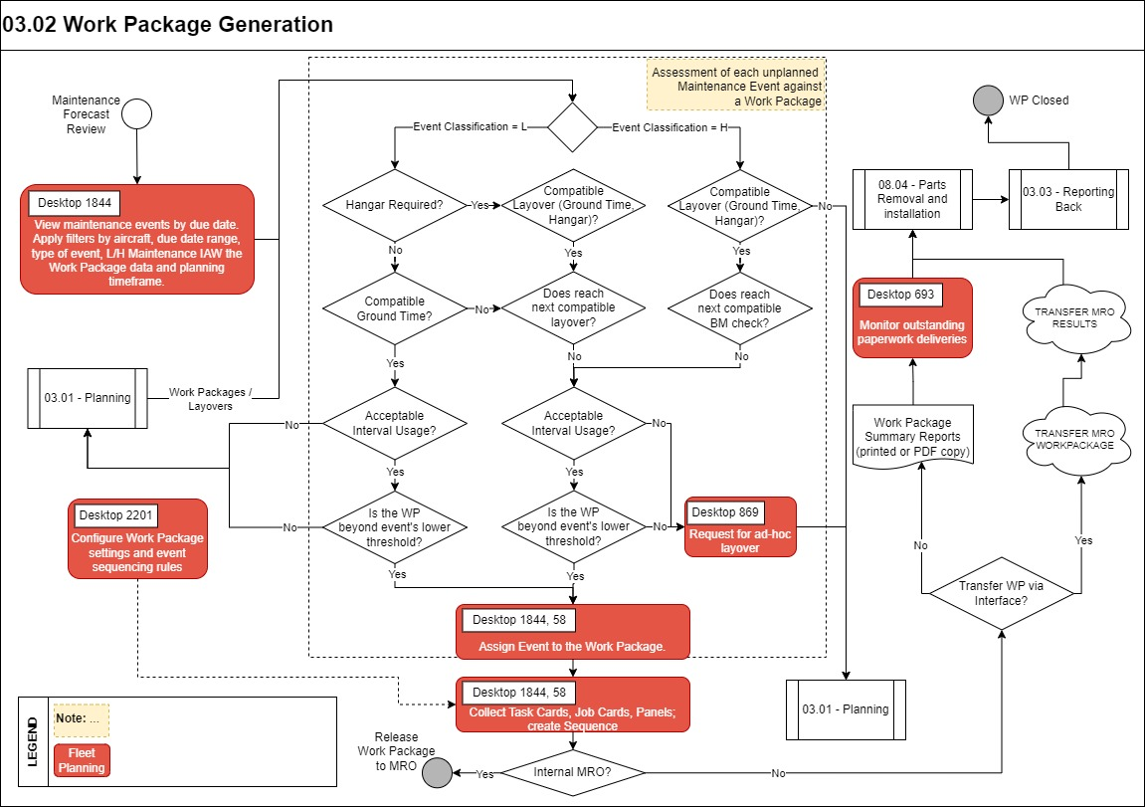
Process Flow Notes:
- Minimum acceptable interval usage shall be defined by internal policy (e.g. 85% for base maintenance, 90% for line maintenance) in order to avoid over-maintenance and subsequent technical, safety, commercial and financial impacts
- The use of Work Packages is recommended in the planning and the execution of both Line and Base Maintenance. The Maintenance Item’s planning dates are linked to either the Work Package start date or to the detail of the Work Package Production Plan: with no work package, not only the Continuous Airworthiness Management and Control is challenging, but also accurate resources and material planning processes are hindered.
- The Configuration of the Work Package settings includes the definition of customised Work Package Statuses and the actions allowed for each status.
- The use of dedicated APIs allows the seamless exchange of Work Package summary and Work Package progress between the Operator’s and an external MRO’s AMOS systems.

Process Design Questions

# | Question | Answer
1 | How is the Planning Department organized? (e.g., by timeframe, by fleet, by ATA chapter, by AC type, Line/Base Maintenance, etc.)
2 | Is the same planning staff assigned with the tasks of drawing up / managing maintenance plans and arranging maintenance items into work packages?
3 | How long in advance are the first revisions of work packages released to the MRO for their preparation and execution?
4 | Are further revisions of the work packages content scheduled at fixed dates before the planned induction date?
5 | How long do work packages remain open for assigning additional items before the aircraft’s induction into maintenance?
6 | What is the capability of your internal MRO?
7 | Is there any contracted MRO for Base and/or Line maintenance? Is AMOS also the MRO software solution of choice?
8 | How long in advance is the tail assignment performed by the flight ops. Planning?
9 | What are the different statuses of a work package from its creation to its closure? Is it worth to differentiate the actions allowed / not allowed in each status? Is it worth to restrict the access to the Work Package by login / login group through different statuses in its lifecycle?
10 | Is the availability of the (internal) MRO resources a driver for the assignment of events to a work package?

Data (Source) Mapping

Data Sources | Description | Volume / Manual / Automatic / Static / Dynamic

Other Software Used

Other Softwares | Used by: | Description

AMOS Configuration

APN 3487 – Maintenance Planning Configuration can be used to configure the Maintenance Forecast behaviour and view.
APN 2201 – Workpackage Configuration allows to define Work Package statuses and the actions allowed for each status, as well as the work package sequencing default rules, types, order and prefix.

Basic Data

Basic Data Table | Notes
Workpackage Priority Codes | Here you can define the priorities of your work packages
Time Requirement Defaults | Defines the default Time Requirement Next Due Calculation Strategy for different kind of maintenance events

Parameters

Parameter Code | Parameter Name | Notes | Comments / Decisions
1264 | WORKPACKAGE SUMMARY LAYOUT | Sets the layout of the workpackage-summary report depending on the int-value.  With the string-value, default sort-order and default amount of W/O-lines can be defined.  With the float value, the default amount of appended empty lines can be adjusted. | Int=0,  Float=0,  String=””
1339 | Taskcard printing and Workpackage issue Workorder behaviour | With this parameter you can decide:  - Amount[Integer]: what document should be printed (task card, WO) when printing a Workpackage that contains Taskcards  - Amount[String]: Indicates if a WO should be issued when a Check or SRT is assigned to a Workpackage | Int=0, String=Y;N;Y
1396 | Related Events Logic | By setting this parameter to `Y`, the Program "View/Edit Workpackage" will also collect maintenance events that are related one to another with the relation code `W`.  When de-assigning a maintenance event from a Workpackage, the collected related maintenance event will be as well de-assigned in case they are not themselves collected through another maintenance event that is still assigned to the workpackage. | String=Y
1470 | Workpackage Groups Settings | With this parameter you can control the behaviour of the workpackage groups. | Int=0, Float=0.00, String=””
1523 | Workpackage Assignment Restrictions | When setting the Integer value to 1, a warning message is displayed whenever a workorder classified as heavy is assigned to a workpackage classified as line. | Int=0, String=””
1640 | WP information on PDF report | This parameter gives the possibility to print workpackage information to all PDF files linked to the Workpackage Summary reports. Data is only added when printing from AMOS (either to a paper printer or PDF printer). | String=N
1653 | Forecast calculation parameters | Integer value (value in hours, value less than zero=disabled): Define a minimum Workpackage groundtime in hours to be considered as non-flying time in the expected date calculation of maintenance events.  Double value (value in days, value not defined or less than zero = default value = 15 days): It defines the number of days considered so that the forecast entries are flagged as "to be recalculated" after a counter update.  String value (value not defined or not a number format = default value = 200): Performance related - see parameter description in APN 1653 | Int=24,  Float=15,  String=200
1687 | Activate the NullLegsFiller daemon | The activation of the NullLegsFiller daemon impacts the calculation of the next due date (using counters other than calendar days) for those aircrafts with days in the past with no flight activity. Without null leg, the average daily values are applied for those days in the forecast computation. | String=Y
1748 | Automatic generation of W/P Summary report | This String parameter controls whether the W/P Summary 2 report has to be automatically generated, saved in the storage engine and linked to a W/P history entry after specific actions. | String=Y;Y
1752 | Panel Creation Configuration (Workorder/Jobcard) | The Integer value of this parameter defines whether to display the Create WO or Create Jobcard button in the Panels tab in the Production tab of View/Edit Workpackage | Int=0
1914 | Jobcard collection | The String value defines if jobcards should be collected for workpackages having an external maintenance provider. | String=Y

Workflows

Workflow Number | Workflow Name | Notes
43 | Publish a Workpackage
98 | After saving, deleting and creating a Workpackage
158 | After deassigning Events from a Workpackage
198 | Publish Workorders in a Workpackage
307 | Before assigning Events to a Workpackage
325 | Before saving, deleting and creating a Workpackage
370 | After assigning Events to a Workpackage
371 | Before deassigning Events from a Workpackage
409 | Dataset Notification | Only if WP transfer via API is used
484 | Workpackage changed

Scheduled Tasks

Scheduled Task Reference | Frequency | Notes
Forecast Sequence, including:  EffectivityApplicabilityService  EffectivityConsistencyTask  RecalculateFutureEventsService  CheckExpiredSoftwaresTask  AircraftMaintenanceForecastService  ComponentMaintenanceForecastService  PartForecastService | Daily
AimFileImportService | Every 4 to 8 Hours | This task can be used to regularly import from a shared directory the file created by an external MRO using the ”TRANSFER MRO RESULTS” AIM Service

API’s & Interfaces

Reference | Direction | Trigger | Frequency
TRANSFER MRO WORKPACKAGE | Export | Manual or WP Status change | N/A
TRANSFER MRO RESULTS | Import | Manual, Webservice or Scheduler Task | Every 4 - 8 hours at least
EXPORT FLYDOCS MRO WORKPACKAGE | Export | Webservice, only used in conjunction with FlyDocs
EXPORT FLYDOCS WORKPACKAGE SNAPSHOT | Export | Webservice, only used in conjunction with FlyDocs
EXPORT WORKPACKAGE CUSTOMER INFORMATION | Export
EXPORT WORKPACKAGE SNAPSHOT | Export

UAT Guidance

Annex – Additional Info

